VITYARTHI PROJECT


ACCOUNT MANAGEMENT SYSTEM

REGISTRATION NO.:25BAI10089
NAME:KUSUMITA
PROGRAM:B.TECH CSE(AI&ML)

INTRODUCTION
This program is designed to help you manage your accounts efficiently. With this system, you can create, view, transaction like deposit, withdraw, and check balance.

Features:
- Create and manage multiple accounts
- View account details and balance
- Deposit and withdraw money
- Check account balance
-A user friendly interface

Note: This program is designed for educational purposes only and should not be used for actual financial transaction

Tasks performed by the program are given below:
1. Create Account
2. View Account
3. Deposit
4. Withdraw
5. Check Balance
6. Exit

PROBLEM STATEMENT

This program allows user to manage their accounts efficiently.
1. Develop a user-friendly interface for account management
2. Implement account creation, viewing and transactions functionally
3. Provide error handling and user feedback mechanisms

Constraints of program:
1. The system should be designed for a single user
2. The system should not persist data between sessions
3. The system should not include any advanced security features
4. The system should be implemented using Python programming language

FUNCTIONAL REQUIREMENTS

- The system should allow users to create new accounts with a unique account number, name, and initial balance.
- The system should allow users to view account details, including account number, name, and balance.
- The system should allow users to deposit money into an account.
- The system should allow users to withdraw money from an account.
- The system should allow users to check the balance of an account.

NON-FUNCTIONAL REQUIREMENTS

- The system should be easy to use and understand.
- The system should provide clear and concise error messages.
- The system should handle invalid user input and unexpected errors.
- The system should be implemented using good coding practices and design principles.

SYSTEM ARCHITECTURE
FLOW:
The user interacts with the UI, selecting options and providing input.The UI sends the user's input to the Account Manager.The Account Manager processes the input, performing the requested action (e.g., creating an account, depositing money, etc.). The Account Manager updates the Data Storage component with the new account data.The Account Manager returns the result of the transaction to the UI. The UI displays the result to the user.
System Architecture Diagram:
+---------------+
| User Interface |
+---------------+
|
|
v
+---------------+
| Account Manager |
| (Business Logic) |
+---------------+
|
|
v
+---------------+
| Data Storage |
| (Account Data) |
+---------------+

DESIGN DIAGRAMS

The UI is responsible for interacting with the user, displaying menus, and accepting input.The menu options component presents the user with a list of available actions (e.g., create account, view account, deposit, etc.).The Account Manager is the core component of the program, responsible for managing account data and performing transactions. The Data Storage component is responsible for storing and retrieving account Data.

## Account diagram
+---------------+
| - account_number |
| - name |
| - balance |
+---------------+
| + deposit() |
+ withdraw() |
| + check_balance() |
Data Storage Diagram:
+---------------+
| Data Storage |
+---------------+
| - accounts |
+---------------+
| + create_account()|
| + view_account() |

DESIGN DECISIONS AND RATIONALE

The following design decisions were made to achieve this goal:
1. Modular Design:
- Decision: Divide the program into separate components, each responsible for a specific function (e.g., UI, Account Manager, Data Storage).
- Rationale: This design allows for easier maintenance, modification, and extension of the program.
2. Simple Data Storage:
- Decision: Use a list to store account data, with account numbers ,name of holder and initial balance.
- Rationale: This approach provides fast and efficient data retrieval, and is easy to implement.
making it easier to manage and extend.
3. Menu-Driven Interface:
- Decision: Use a menu-driven interface to interact with the user.
- Rationale: This approach provides a simple and intuitive way for users to navigate the program and perform actions.

TESTING APPROACH
System Testing: Test the entire system, including the user interface, to ensure it is working as expected. Test the system with real users to ensure it meets the requirements and is user-friendly.
The following are some test cases for the Account Management System:
- Test creating an account with a valid account number and name
- Test depositing money into an account
- Test withdrawing money from an account
- Test getting the balance of an account
- Test creating an account with a valid account number and name
- Test viewing an account
- Test depositing money into an account
- Test withdrawing money from an account
- Test checking the balance of an account
- Test entering invalid input choice

SCREENSHOTS/RESULT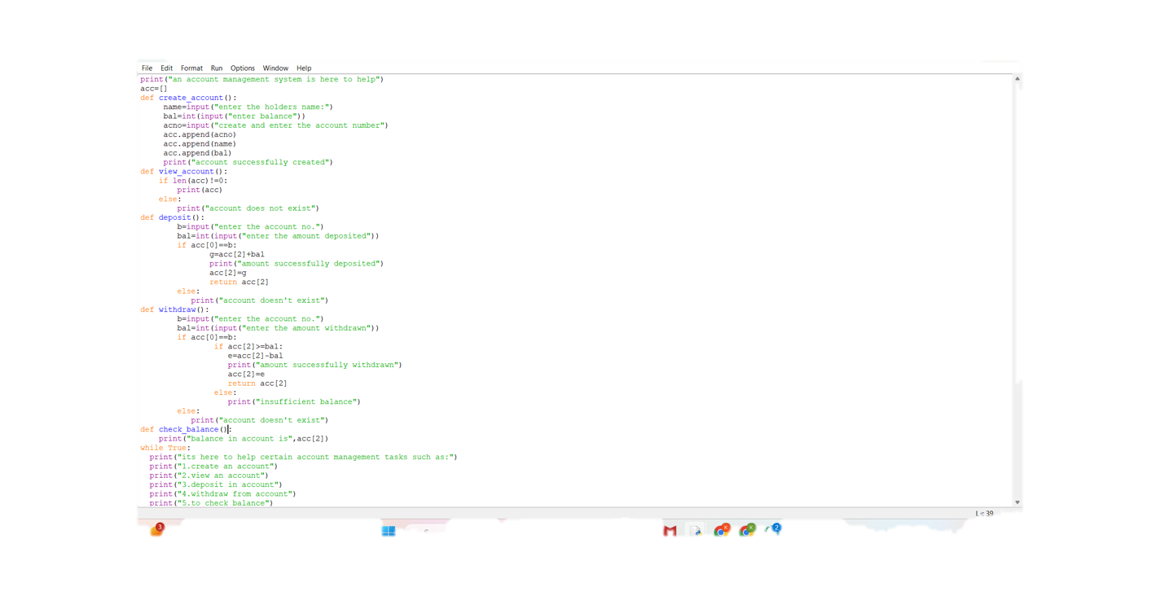

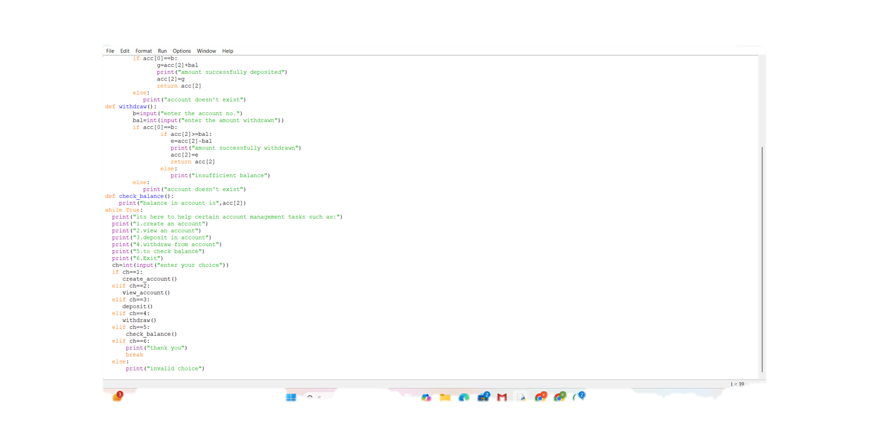

OUTPUT
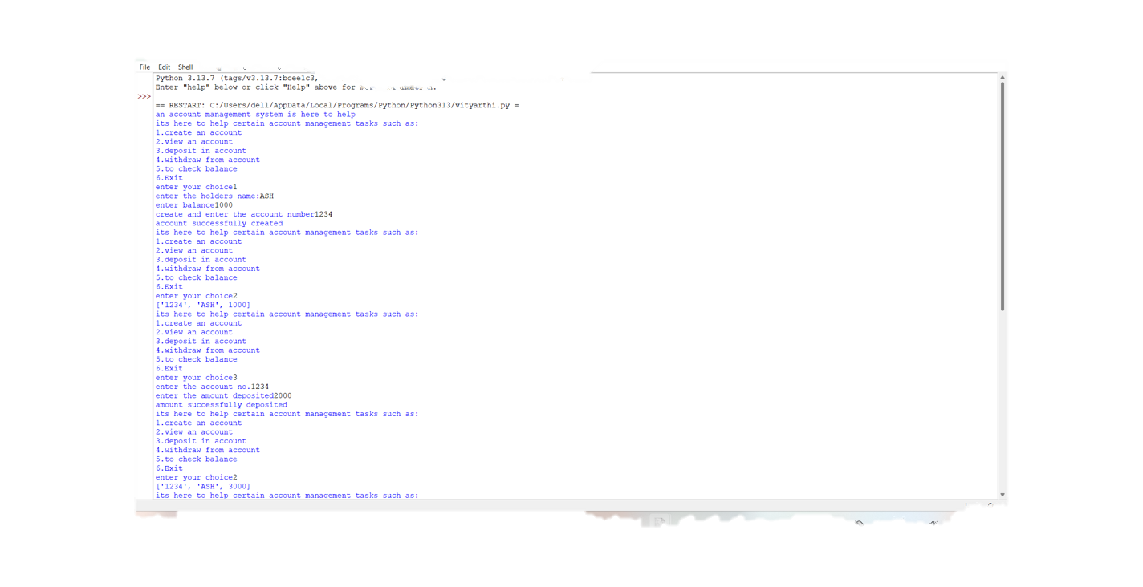

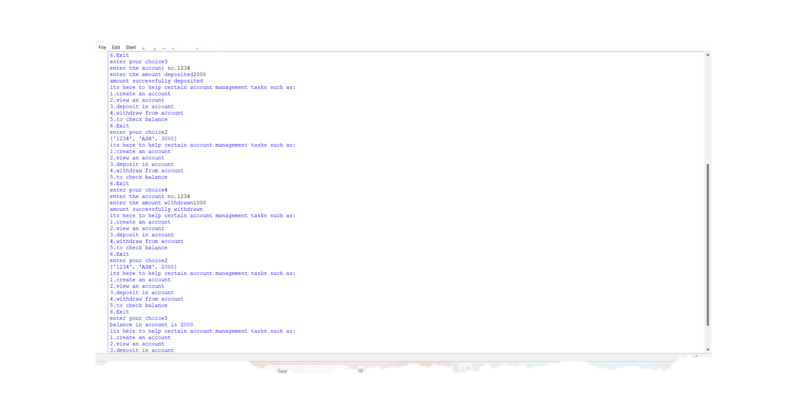

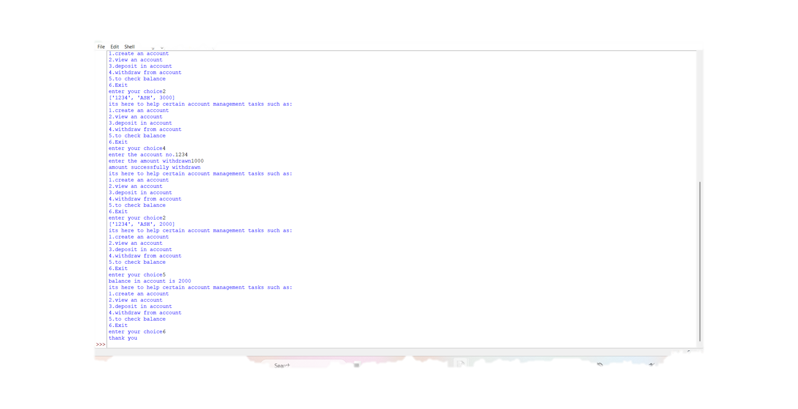

CHALLENGES FACED

1.The data should be retained even after the program is closed. To overcome this, we can use a database or a file to store the data.
2.Another challenge was to handle errors and exceptions properly. We need to ensure that the program does not crash when an error occurs, but instead, it should display a meaningful error message to the user.
3.Ensuring the security of the program was also a challenge. We need to ensure that the program is secure and the data is protected from unauthorized access.
4.Designing a user-friendly interface was also a challenge. We need to ensure that the interface is easy to use and understand.
5. Validating user input was also a challenge. We need to ensure that the user input is valid and consistent.

LEARNING AND KEY TAKEAWAYS

1. Planning is essential before starting a project. It helps to identify the challenges and come up with solutions.
2. Testing is essential to ensure that the program is working correctly. It helps to identify the bugs and fix them.
3. Security is essential to protect the data from unauthorized access. It is important to use encryption and access control to ensure the security of the program.
4. User interface is essential to make the program user-friendly. It is important to design an interface that is easy to use and understand.

FUTURE ENHANCEMENTS
The following are some future enhancements that can be made to the Account Management System:
1. Multi-User Support: Currently, the system only supports a single user. In the future, we can enhance the system to support multiple users, each with their own account and access rights.
2. Transaction History: We can add a feature to display the transaction history of an account, including deposits, withdrawals, and transfers.
3. Transfer Funds: We can add a feature to transfer funds from one account to another.
4. Bill Payment: We can add a feature to pay bills, such as electricity, water, and phone bills, directly from the account.
5. Automated Alerts: We can add a feature to send automated alerts to users, such as low balance alerts or transaction alerts.

REFERENCES
-COMPUTER SCIENCE WITH PYTHON BY SUMITA ARORA CLASS 11&12
-GEEKS FOR GEEKS
-W3SCHOOLS
-META AI

